Name: ______________________________________ Group: _____________

Contemporary Period: 1970-today (notes/review)
Population Trends:
1. Baby boomers: They continue to have an impact (they are reaching the age of retirement)

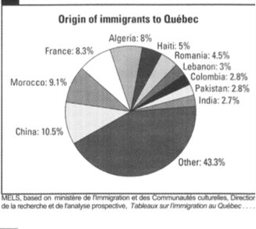
2. Multiculturalism: Canada & Quebec are increasingly multicultural.
Reason: Immigrants coming from many places such as Haiti & Southeast Asia.
Impact: Presence of many cultures, different places of worship, ethnic neighborhoods, ethnic art
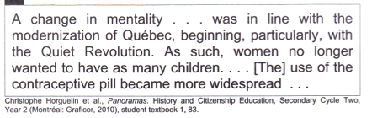

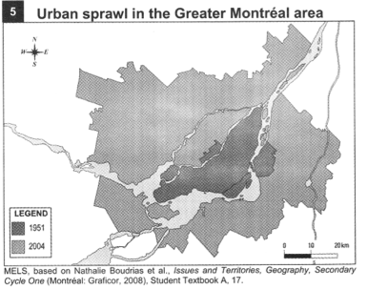
3. Urban areas: Most people live in urban areas.
Reason: jobs, proximity to services, etc.

“Urban Sprawl”: Suburbs and services in suburbs develop outside major cities. (South Shore of Montreal)

4. Quebec:
Immigration: Has special privileges, can favor French speaking immigrants over non-French speaking ones.

Economic Trends:
1. Globalization:
What is it?: Look at what you are wearing, where was everything made? This is because of globalization. The idea that products can and should come from everywhere, usually where it is cheapest.

2. Changes to agriculture: Focusing on organic production, reduction of farming areas.

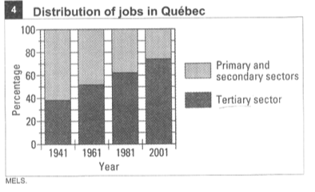
3. Sectors of the economy:
Primary & Secondary sectors are less important: Both sectors have to do with the collection & transformation of natural resources (mining, forest industry etc).
Tertiary(service sector) & Quaternary (knowledge based, usually research, financial planning):
These sectors have become the most important.

4. Workers demands: parental leave, better pension plans, better work schedules.
5. Economic Recessions: A recession is a baby version of an economic depression (not as harsh).
Canada has experienced 2 since 1980, we are currently at the end stages of one. Usually whatever happens in the United States has a big impact on Canada.
Impact of recessions: People lose jobs, companies downsize, stocks go down, number of unions goes down (people are more worried about keeping jobs than getting better conditions)
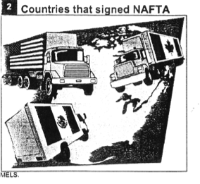
6. North American Free Trade Agreement (NAFTA):
a) Canada signed a FREE TRADE agreement with the
United States in 1988.
b) Mexico signed as well in 1992.

7. Neo(new) liberalism:
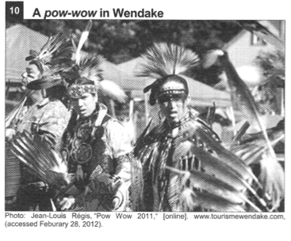
What is it?: Instead of it being about freedom of speech and equality, it’s about the economy: Free markets, individual responsibility, reduced government intervention in the economy.

Cultural Trends
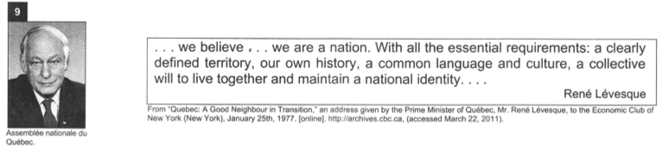
1. Aboriginalism: it is about preserving native culture and protecting native languages. Trying to salvage what little of the culture is left.

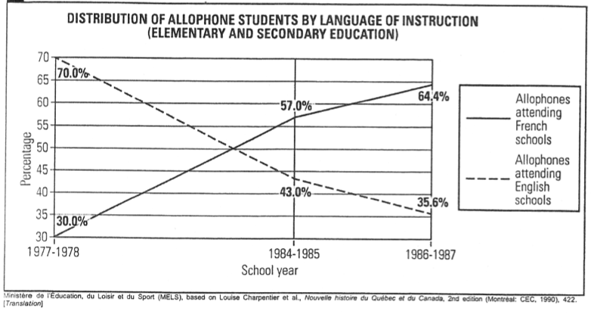
2. Quebec Nationalism:
a) What the nationalist movements are asking for:
- More independence for Quebec
-Laws to protect the French language (Bill 101, Office de la Langue Francaise)

b) Referendums (voting on the separation of Quebec from Canada):
-1980:
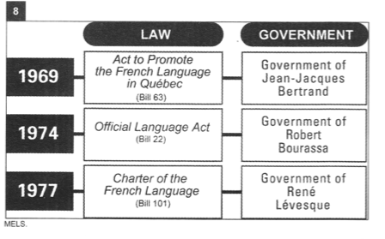
Federalists: Prime Minister- P.E. Trudeau, Jean Chretien, Claude Ryan
Sovereigntists: Rene Levesque, Jacques Parizeau, Camille Laurin

Leading up to the Referendum:
Prime Minister Truedeau promised that if the “No” side won, he would change the Canadian constitution to meet Quebec’s demands for more provincial power.

Results:
Yes: 40.44% (1,485,852)
No: 59.56% (2,187,991)
Invalid or blank votes: 1.74% (65, 011)
Voter turnout: 85.6% (2008 provincial election turnout: 57.4%)

-1995:
Federalists: Prime Minister-Jean Chretien, Quebec Liberal Leader- Daniel Johnson, Federal Progressive Conservative leader- Jean Charest

Sovereigntists: Quebec Premier-Jacques Parizeau, Bloc Quebecois leader- Lucien Bouchard
Results:
Yes: 49.42% (2,308,360)
No: 50.58% (2,362,648)
Invalid or blank votes: 1.82% (86,501) *Big controversy: mainly “no” votes were considered invalid
Voter turnout: 93.52%

Trends in Official Power & Countervailing Powers
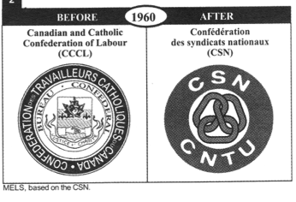
1. Church & the State: Influence of the Catholic Church or any religion is restricted to personal life.

2. Native Peoples & the State:
Main event: James Bay Agreement (hydroelectricity project)
- The government announced a plan for a huge hydroelectric project in the James Bay area. ------ They had not consulted the people living there (primarily the Cree).
- The native people were very upset by this and fought.
- Only after did a lot of negotiations take place between the Cree and the Government.
- The Cree ended up getting some financial compensation for this project

3. Social justice & environmentalist groups:
- These groups are looking to get the government to implement policies to protect the environment and people that need help.
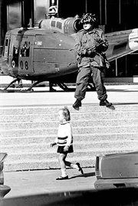
- Social justice groups want: fair distribution of wealth, social housing programs etc.

4. Linguistic Groups & the State:
The Front de libération du Québec (FLQ) English: Quebec Liberation Front
An extremist group.
The October Crisis:
In October of 1970 the FLQ kidnapped James Cross & Pierre Laporte.
After they were kidnapped, the FLQ made demands.
When their demands were not met, Pierre Laporte was killed.
Prime Minister Trudeau put the War Measures Act in place (heavy military presence). This is the only non-war time that the War Measures Act is put in place.

