Name:____________________________________ Group: _____________

british rule I: 1760-63

the fall of new france

**How the French Regime Ends**

1. _________________________________: _____________________

a) War between _________________ and _________________. In __________________ AND ___________________________.

b) ____________ loses the war.

2. **Reasons for Britain’s success**

a) _________________________

b) Colonies in ______________ are very ______________________.

c) ______________ soldiers

3. **Reasons for France’s failure**

a) They focused more on ____________________________________.

b) _______________________________

c) _________________ soldiers

d) New France: ________________________________________________________

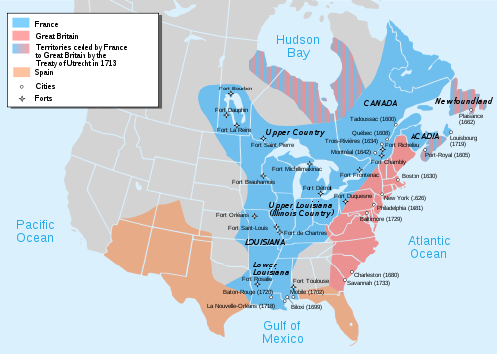e) Colony was controlled by _________________ (too _____________________)

4. Important Dates:

**The Fall of Quebec City:**

**The Capitulation of Montreal:**

**The Treaty of Paris:**

5. **Royal Proclamation-**

a) Main goal: _________________________________________

b) How did they plan to accomplish this:

1. Create _______________________

2. Established __________________________

3. Immigration: No ____________________ allowed in ________________________________________

4. Adopted _______________________ (__________________) _________ and _____________________ laws.

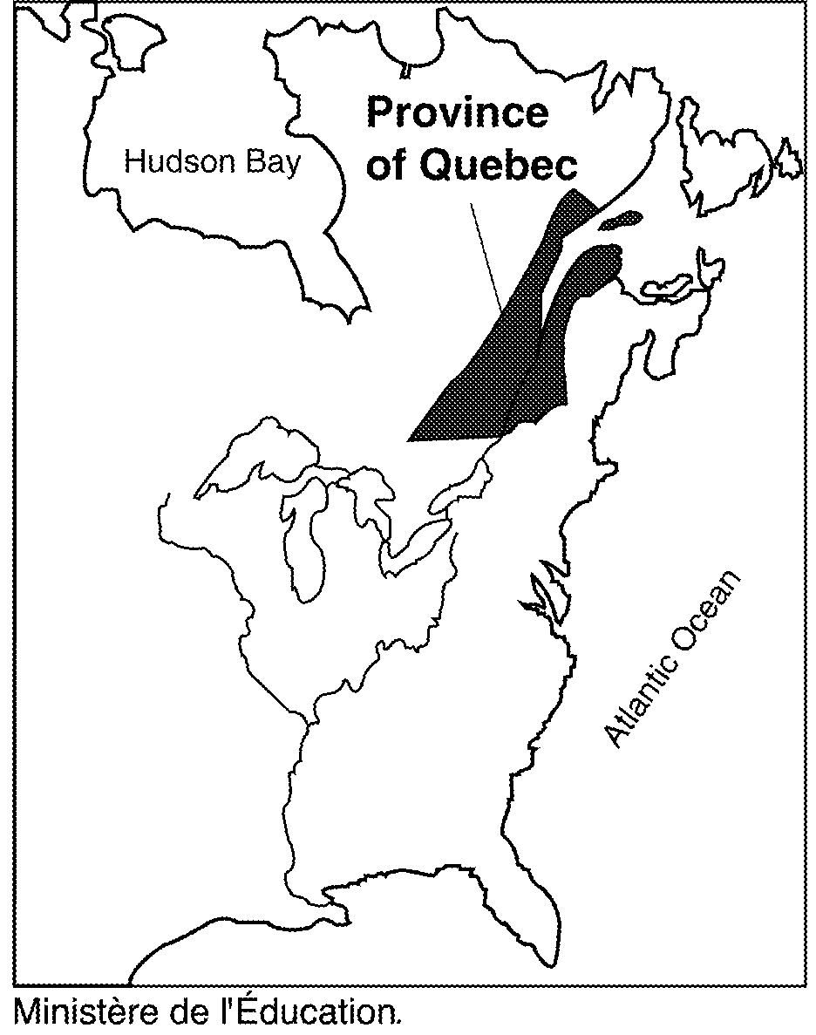5. Encouraged the _________________________________________.

6. Adopted the ________________________________.

7. Made the ________________________ smaller.

**8. Impact of Royal Proclamation on the Amerindians**

a) The _______________________ go from being ________________________________ to ____________________________________.

b) The state decides they are more of a ______________________ than anything else and they start to do things to ____________________ and ________________________ that problem.

**c) Start of the Reserve System**

The whole idea started with ___________________________________ (1763), where the British Government ____________________________ to the Amerindians that they were supposed to live on. It was called _____________________________________.

D) Royal Proclamation created the “____________________________________”

Now any “________________” with the Amerindians had to go through the Indian Department.

E) Between _____________________ and ____________________, the Amerindians lost a lot of their __________________________.

**Amerindians during the British Regime**

**Population**

1. Around 1800 there are ________________ Iroquois and Algonquin living in the ______________________________.

2. Effects of ____________________________________:

a) “___________________________”: many Amerindians become more __________________.

b) _________________ and ____________________ grounds are reduced _____________________________________________.