Name: _____________________________________ Group: ___________
The British Rule II: 1763-1791
Population: 1763
1. The general composition of the population:
a) 65 000 inhabitants
b) Mainly Canadien
c) Some Amerindians and a small black population (some were slaves)
Economy: 1763-1800
Fur Trade: The economy is still based on furs.
It is still the main source for ____________________________.
1. Changes after the ________________________:
a) ____________ fur trade merchants replaced by ____________________________.
b) Territory expands _________________________ and now includes areas around the ________________________________ and ____________________________.
c) __________________________________: Hudson’s Bay Company, _____________________
d) More _____________________________________________.
e) Resource ( ______________________) is eventually ________________________ (not enough).
Causes of the Quebec Act & their effects
1. ____________________________ (British)
a) 1760: _________________ governor of __________________________
1763: ______________________________________
b) He is VERY ________________ because he ________________________________________
_____________________________ even though he was ______________________.
c) He _________________________ the habitant _________________________.
d) He ___________________ French Canadian ___________________, ______________________________ and ___________________.
e) He was essentially kicked out of Quebec for trying to __________________ his ideas.
f) His ______________ were eventually addressed in the ___________________________ in 1774, even though he died in _______________.

2. The _____________________________________ (1776-1783)
a) The _____________________ (American) _____________________ wanted ______________________________________________.
b) Influenced by the NEW idea of _________________________, a war (___________________) began, and the ___________________________________!

3. The _________________________
a) Just like with anything, not everyone was in favor of the revolution.
b) The ________________________________ caused a new group of _____________________ to settle in ________________________________ and __________________________________.
c) The _____________________ were: The ______________________ people that were still _______________ to the ________________________.
d) _________________________________________ was the most logical place for them to settle since they were still a ____________________________, and it was much closer than going all the way back to ______________________.
4. Impact of the American Revolution
a) The British REALLY did not want another _____________________ in one of their _____________________.
b) They were afraid that the people in the _____________________________ would rebel.

Quebec Act: 1774
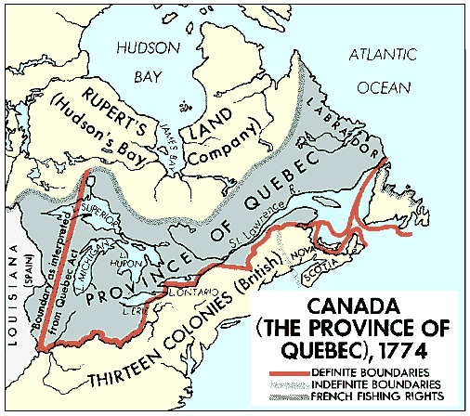
1. Goal: _____________________ or _______________________ (be nice) the ____________________________________.
2. What did it do?
a) ____________________________________.
b) ________________________________________ came back.
c) _____________________________________ came back.
d) _____________________ is abolished, so ________________________________ could take public posts. (Catholic Church gets its power back)

