Name: _____________________________________ Group: ____________

British Rule IV: 1837-1848

**Population**

1. Composition in 1840:

a) Inhabitants: ____________________________

b) _____________________________________________

_____________________________________________

2. Changes in overall composition:

a) 1845: Montreal becomes mainly ________________________

b) 1851: Canada West (____________) population is bigger than Canada East (_____________)

**Economy**

Agriculture

1. **Main crops in Lower Canada**: __________________, ______________, _________________

2. Target markets (_________________________________): ______________________ and ___________________

3. **Effects on transportation**:

a) Increased the creation and use __________________ and _____________________.

b) Faster to __________________________ AND ________________________________.

4. **Decline in wheat production in 1830’s**:

a) Problems: _________________________________________, __________________________________________________ (crops not growing).

b) Effects: HUGE amount of ______________________________ leaving for the ______________________________ (Massachusetts & Maine).

Why there? _________________________________________

c) Farmers “solutions” to the poor farming conditions:

moving to ________________________________________ (Mauricie, Saguenay & Laurentians)

________________________ to the USA

5. **Free Trade**:

a) Britain gets tired of buying things from their _____________________.

Mainly because they _________________________________.

b) They ____________________ their “_____________________” policies in 1847 and adopt a ______________________________________.

They want to find the _________________________ instead of ______________________ their colonies.

c) Result: _____________ starts looking for a _________________________.

**What country will they choose**?

d) BNA signs the ________________________________ with the US which lasts from ___________________________.

e) ________________________________ were abolished on major products.

f) Canadians _____________________ their economy even more to suit ____________________________________.

**Power: The Lower Canada Rebellions**

**Causes of the rebellions**

1. Life is not good:

a) _________________________________ (huge crop failure in 1833)

b) _______________________ of the ______________________________________________ becase they were exculded from the ____________________ and ___________________ councils.

c) Restricted access to ________________: ________________________are overcrowded

= __________________________________________________

2. New Laws:

a) Law to make __________________ one of the official languages ( )

b) Tax on wine and tea

c) Tax __________________________ to finance construction ( )

d) A bill to grant a ____________________ for the Legislative Assembly ( )

3. LIBERALISM:

a) What is it? ___________________________________________________________________

______________________________________________________________________________

b) Characteristics: ________________________________, ____________________________________, _______________________________________

c) The _____________________________ and __________________________________ are examples of __________________________________

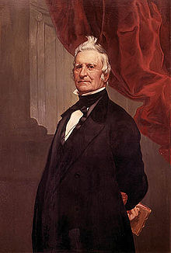4. Louis Joseph Papineau

a) Member of the ______________________________________

b) Defender of _______________________________ interests

c) Leader of the _____________________________ (later the __________________________)

d) Demanded a more _______________________ politcal system

e) ________________________ to favoritism/_________________________ of the ___________________________________.

5. The ____________________________________________

a) Was a list of ____________________ sent by the ___________________________ to the ______________________________

b) What they wanted: __________________________________________

________________________________________________________

6. The _________________________________ or _______________________________(1837)

a) This was __________________________________ (written by Lord Russell) to the _____________________________________.

b) They basically _____________________ the Patriotes ______________________

c) What is frustrating about this?

**The Rebellions**

**Official power (BR gov’t)**

**VS**

**Countervailing Power (Patriotes & Lower Canada Legislative Assembly)**

1. At first _______________________ does not want to resort to _____________________.

He and members of the Patriotes hold ____________________________________ and ______________________. They speak out in public ( ).

***“While we do want reform, we have never intended to achieve it through brute force, but only through peaceful, legal and constitutional means” -Etienne Parent***

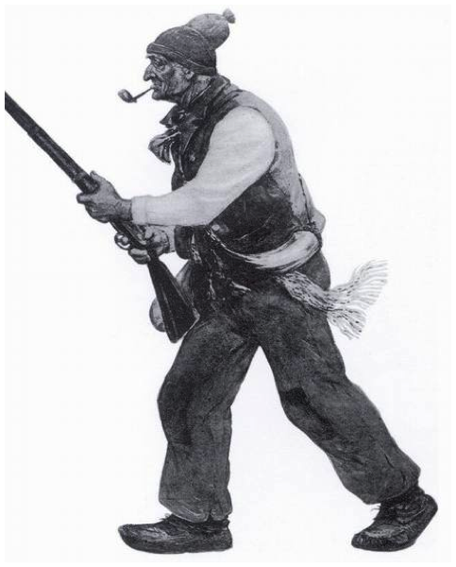2. Eventually they realize that this is not working, and resort to a ___________________________________________.

3. There are 3 battles in all:

1)

2)

3)

4. The ______________________ __________ the first battle. But ____________ the other 2.

5. The British “win” the _____________________________________________.

6. Papineau _____________________________________________, and stays there until 1845.

**The Effects of the Rebellions**

**The Durham Report**

1. After the _______________________, the British appointed __________________________ as Governor General of _____________________________.

2. His job was to _____________________ the ______________________________________.

3. In __________ he made his final report; it was called the ___________________________.

4. His report said that the _______________________________________ becase the colony’s economy was _____________, and because of the “________________________” of the ___________________________ population.

5. He thought that the __________________________________ was contradictory because the _________________________________ did not actually allow its members to ______________.

6. He said the ____________________________________ should give more power to the ___________________, by giving them ___________________________________.

7. He also said that political problems were made worse in Lower Canada because of ________________________________________.

8. He suggested that the solution was the _____________________ of _______________ and ____________________ Canada.

**Durham report quotes:**

*“The French Canadiens are a people with no history and no literature.”*

*“ I found two nations warring in the bosom of a single state.”*

*“The superior political and practical intelligence of the English cannot be, for a moment disputed.”*

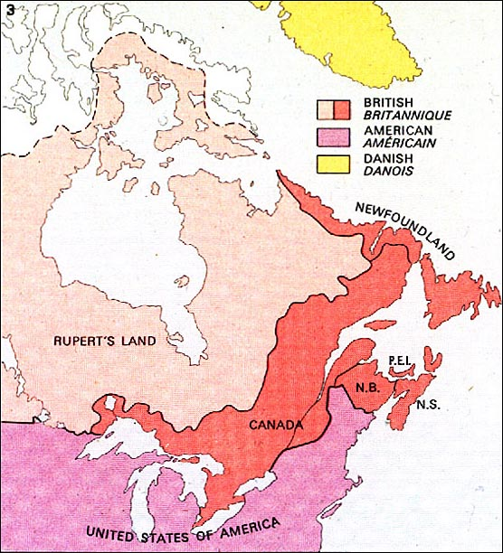**The Act of Union (1840)**

1. In _____________, the _________________________ created the ________________________________________.

This consisted of ________________________________ and __________________________.

2. The British ______________________ the idea of _________________________________.

3. Canada East and Canada West both had the same amount of ____________________________________________.

4. Because the population of ____________________________ was larger, ________________________________ were not equally represented.

**Responsible Government (1848)**

1. In ________________, United Canada is granted ___________________________.

2.

They have been asking for this for a VERY LONG TIME!!!!!

British Regime V: 1848-1867

**Population**

1. ________________________________________________

a) New Group of immigrants coming in: ________________

b) They speak ________________________ and are ________________________.

c) They are desperate and want to ___________________.

d) They are willing to work for _________________________ than the ____________________.

e) They ______________________ feel ______________________ by them because they are _________________________________ and they are ___________________.

**Culture**

Two ____________________________ ideas emerge

1. ______________________________: The idea that the ____________________________ are above all others.

a) Characteristics: _______________________________________________________________

______________________________________________________________________________

b) Key figures:

______________________________________: An army created to defend the Papal states.

______________________________________: He was the bishop of Montreal

He helped expand the __________________ of the ___________________________ in Quebec.

He commissioned the building of ___________________________________________ (now called Mary Queen of the World)

2. _______________________________:

a) An idea which ______________ the _______________________ and _____________________ of the church in _______________________________________________.

Challenges ______________________________.

b) Key figures:

__________________________________________: They created their own library and would hold lectures and debates there.

They had books from Voltaire which had been deemed immoral by the Catholic church.