Name: ____________________________________ Group: __________

The Great Depression: 1929-1939
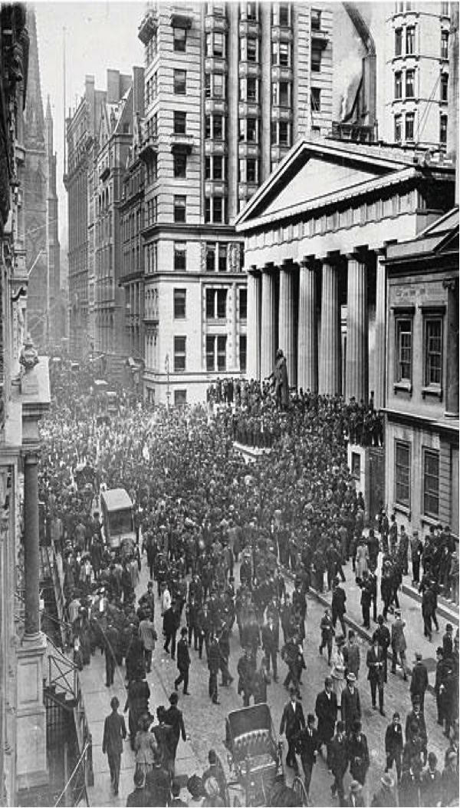
Causes of the Great Depression
“The “Roaring Twenties” came to a sudden end on October 24, 1929, when the New York stock market crashed… All the countries in the capitalist world were affected.”
There were many reasons but most analysts agree that it was triggered by the ___________________________________
of October 24, 1929 also known as "Black Thursday". From the Thursday to the Monday over 16 trillion shares were sold. This panic selling led to the beginning of the end.
Combined with governments laissez faire policies the Depression started and lasted until 1939 and the start of WW 2.
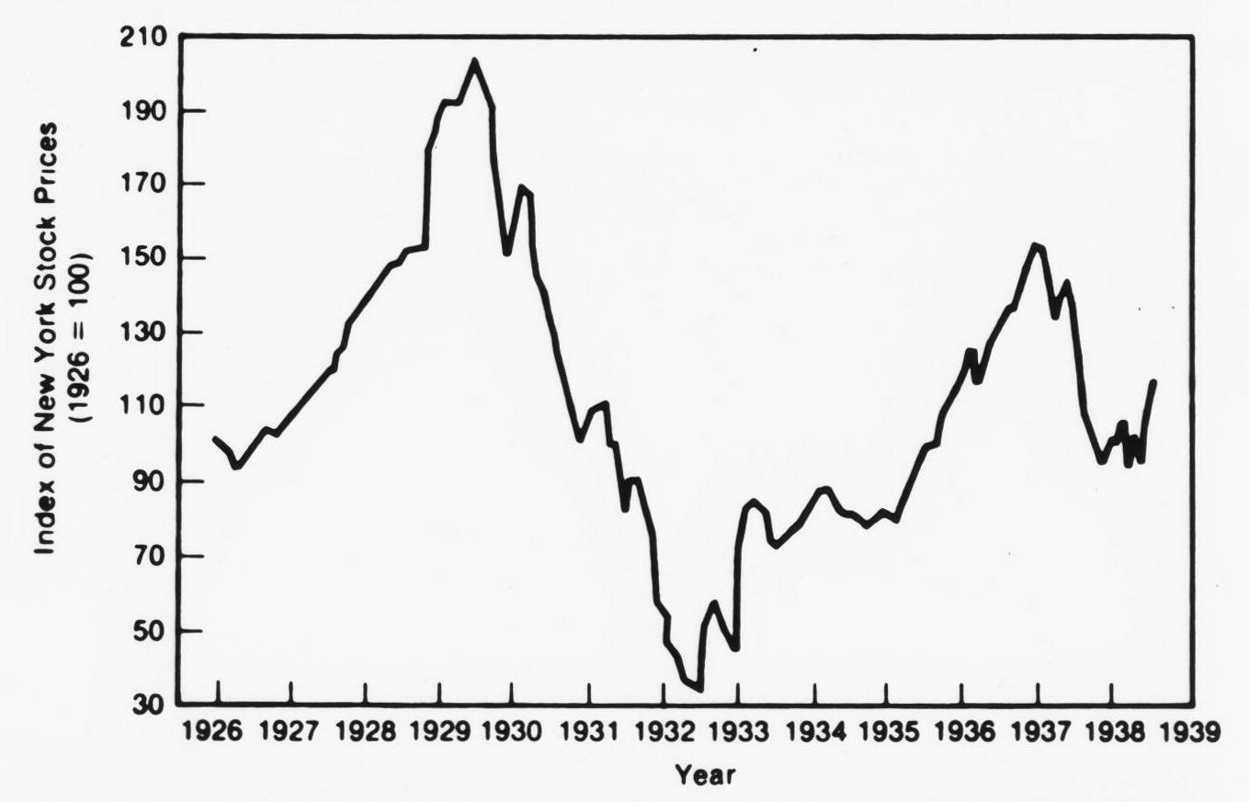

1. _____________________________:
- When the ___________________________
started to go down, people started to panic.
- They tried to sell all of their stocks to save money.
-This day is known as Black Thursday
- Banks RAN OUT OF MONEY to lend.

2. _____________________________ & _________________________:
- Companies expanded a lot and as a result they _________________________________
___________________________________________________.
- When a company cannot sell what they are making, they are not doing well.

3. ____________________________:
- Many people were ___________________ money from ___________ to buy things.
- People mostly bought stocks.
- The Stock Market was new, and people bought stocks without really knowing what it
was about.

4. __________________________________________:
-When the Stock Market began to decline in the U.S., Canada felt the effects.
- Why? The Canadian economy relied heavily on the American economy.

5. ________________________________________:
- The ___________________ were hit by a drought which lasted for many years.
- The economy of the Prairies relied heavily on ___________________________.
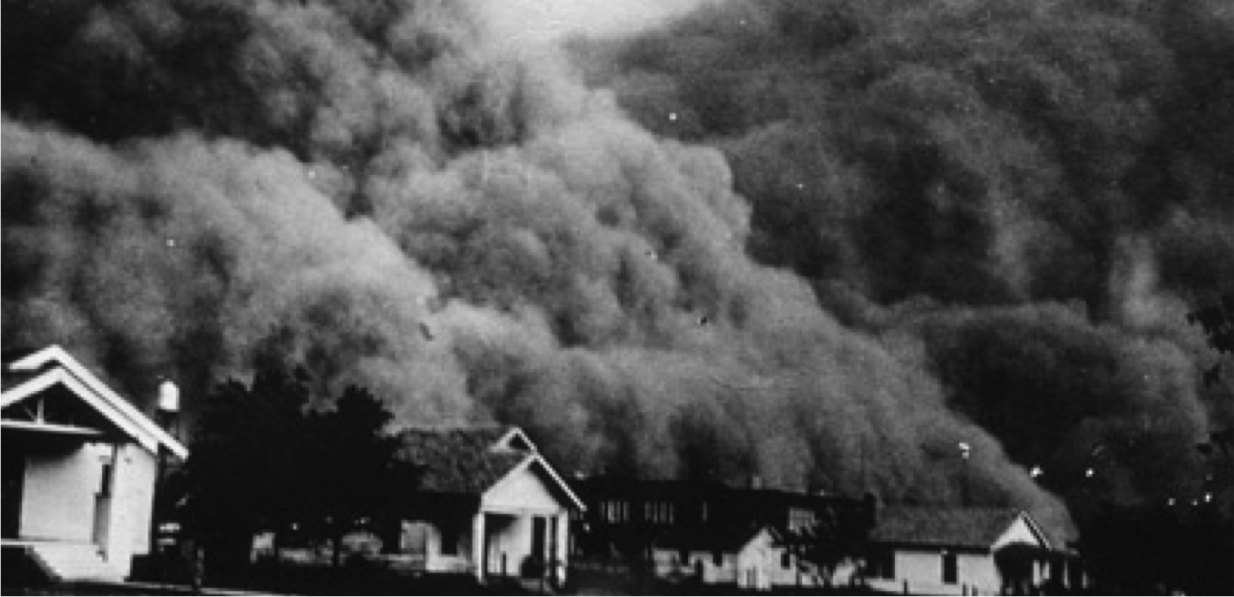
- ________________ + ______________________ = _____________________________
“ In the 1930s, it wasn't just a natural weather phenomenon that gripped the heart of the nation, it was an extended dry spell coupled with poor farming practices and misuse of land that turned much of the Great Plains into what would come to be known as the Dust Bowl.”

Effects of the Great Depression

Economic Effects:
Unemployment among Canadians in the Great Depression reached an estimated 30% of the work force by January 1933—a proportion never seen before or since.
- People could not repay loans
- ___________________________________
- Prices fell (but people had no money anyways)
- _________________________________________
(pulp and paper, mining)
- Wheat production goes down
- Construction industry loses contracts
- Exports are down
- People have ___________________________________, so public help goes down

Individual Effects:
- ____________________________ = ___________
- Pay cuts for ______________________
- Farmers had to sell things cheaper
- ____________________________
- ________________________ (Being forced out of your home because you cannot pay rent/mortgage)
- Fewer marriages and fewer children
- High demand for help from charities
- More _______________ to __________________ migration

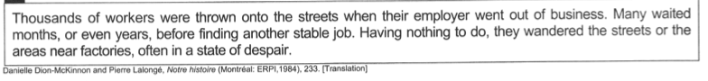

Reactions to the Great Depression (Government Solutions)

As the depression worsened, government intervention was used to better the situation however the benefits were limited.

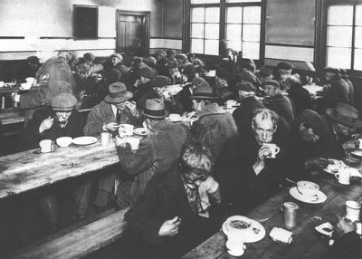
1. ______________________________:
People were employed to _________________________ etc., as a way of giving them work.

2. ___________________________:
- 56 million dollars spent in Quebec
- __________________________ giving _________________ only to those in dire need. (for food, clothing, etc.)

3. ___________________________:
- Unemployed, single men were sent here to do ________________________________________.
They were paid 0.20$ a day.
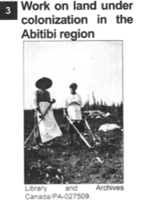
4. ______________________________________:
- Churches and charities set up soup kitchens and shelters, where destitute people could get assistance.

5. “_______________________________” movements:
- The Quebec government (MAURICE DUPLESSIS), with the support of the Catholic Church, encouraged families to move from the cities to colonize and to settle the Abitibi, Gaspésie and Côte Nord regions. This "back-to-the-land" movement ______________________ because farms were isolated and located where the soil was ___________________ and the growing season was _____________________.

Indirect or “Spin-Off” Effects

1. The development of __________________________________ and _________________________:

_________________________: A political and economic theory that the “_____________________________” should own and control businesses. Also, that the ________________________ should provide most people with ___________________________
Western Canada: CCF
Cooperative Commonwealth Federation
Launched by Prime Minister R. B. Bennett in 1935… the Employment and Social Security Act promised a minimum wage, federal regulation of working hours and conditions, unemployment insurance, health and accident insurance, and an enhanced old-age pension scheme, among other measures. However, as many of these measures infringed upon provincial authority as outlined by the British North America Act, they were declared unconstitutional and never put into practice.
Socialist Farmers

Quebec: Union Nationale
Maurice Duplessis, very rural, very catholic

2. Increased government presence in economy and social fabric of Canada.

Policies Initiated by Prime Minister R.B. Bennet
- Bank of Canada in 1934 was created to control money supply.
- Stimulating economy via public works.
- Money from “well-off” provinces helping to support poorer ones.
- ______________________________________
- ________________________________________________
- Aid for farmers
- Higher import duties to protect Canadian industries
- Federal government = increased presence in politics
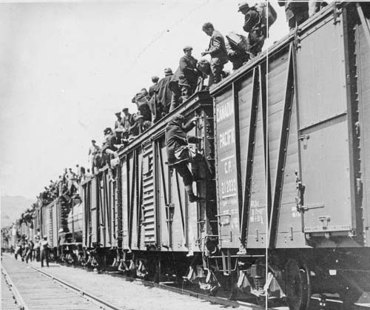
The organized unemployed did win some improved conditions for relief recipients, and they left some immediate and long-term legacies. The hated federal relief camps were abolished by the new Mackenzie King government in 1936. A federal unemployment insurance system, always one of the main demands of the organized unemployed, was implemented in 1941. The organized unemployed of the Great Depression were in many ways pioneers of the socially positive state developed in Canada from the 1940s.

Strikers from unemployment relief camps established by the federal
government in British Columbia and Ontario on their way to Ottawa to
complain about camp conditions, 1935. Their journey was stopped in Regina.
The End of the Great Depression

