Population
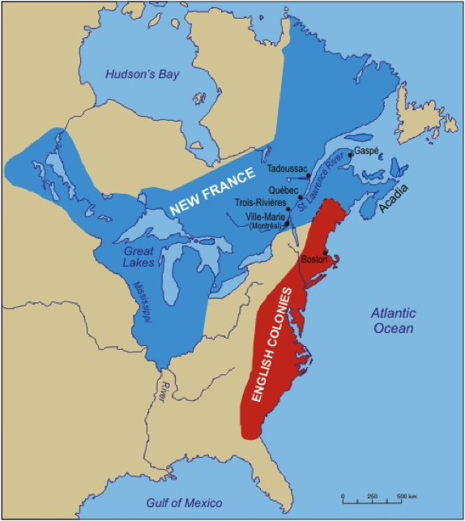
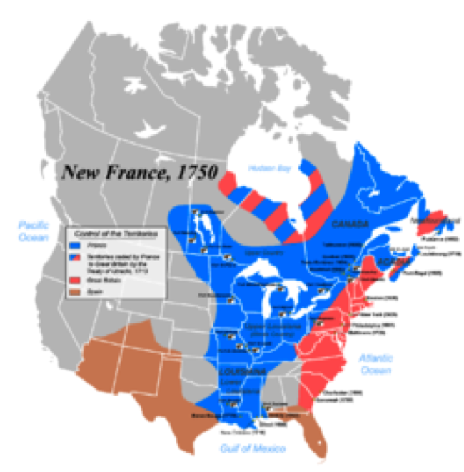
1. Territory continued to _______________________ due to ______________________ of the ______________________________.

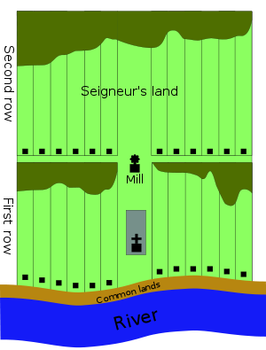
2. Composition of the population:
a) 1663:
Total: _________________
__________________________________________________
__________________________________________________
b) 1760:
Total: ____________________
Mixed population:
__________________________________________________
__________________________________________________
3. Main reason for population growth:
a) _______________________________________
b) Traditional ____________________ families are _____________________.
____________________________ promoted large families.
c) It was not uncommon for families to have 10 or more children.
4. Seigneurial System:
a) ________________ method of organizing the ____________________.
b) _______________________________ of land along a body of ________________.
c) Components of each seigneury: _____________, _____________________________, ___________________, _____________________________.
Economy
Triangular Trade
1. There was ongoing trade between ____________________, ___________________ and the ____________________________________.
2. How triangular trade works:
a) The ___________________ provide _________________________
b) The ____________________________ would ____________________ those raw materials into _____________________________.
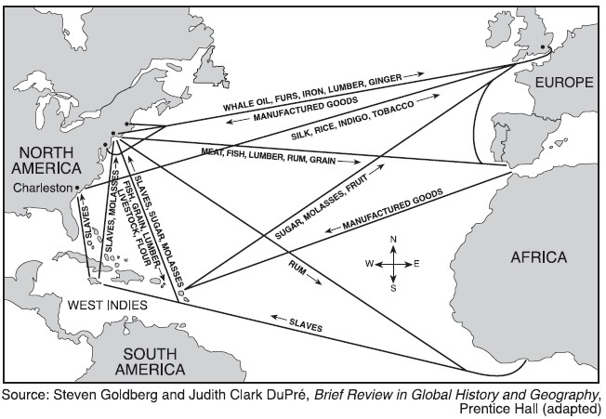
c) The __________________________ would then sell the _____________________________ to the _____________________. (usually for a ridiculous amount of money)

Diversification
1. With the help of ____________________ and other __________________ (Hoquart etc.) the economy of New France became ________________________.
Meaning: the economy does not rely solely on the _______________________.

Agriculture:
1. Population _______________ led to an increased demand for ______________. Mainly ______________. (Those babies need to eat!)
a) __________________________ encouraged the creation of more ___________________, this created a __________________ in goods, which could now be _____________________________________.
b) __________________ becomes a _________________ product.
2.Impact on the land:
a) Further development of the ________________________________
b) Construction of ___________________
c) More ______________________________
3. Impact on the people:
a) ________________________________________________
b) Economy was no longer based on _________________________________
c) Higher demand for _______________________________________
d) Increased number of people in _________________
Shipping and Ironworks
1. Demand:
a) ___________________ needed ______________ for its _____________ and to export products to their colonies (remember triangular trade….)
b) Many ________________ expanded because of this: ________________________________
2. Impact on the land:
a) Mineral _____________________ for ______________________ in the _____________________ (in the Canadian Shield)
b) New _____________________________________
Problems with the economy during the French Regime
1. The economy of New France became ______________________ on _____________________________ from their ________________________________.
2. The _________________________ is still the ________________________________.
3. ________________________________ being made in _________________________.
4. Not enough _______________________________________.

Culture
1. Continuity:
a) Catholic religion continues to play a big role.
b) The idea of _______________________ still dominates.
(symbolsof the King are everywhere: ______________________________)

2. The ____________________________________ of the ______________________.
a) Because of the ___________________ and ___________________________ from the mother country, the _______________________________________ (habitants) were forced to _______________________________________________.
b) They developed an “ ____________________________________”
c) Their contact with the ________________________ helped them to do this.
They _________________ the 2 cultures to create their own.
d) Examples: use of ______________________________, ____________________, building new types of houses to suit the weather, __________________________ without a permit.

Power
1. The State and the ______________________________ of the colony:
a) The ___________________, _____________________ and ____________________ (The B.I.G. 3 of _______________________________) all demanded things from ______________
Examples: More _________________, more ___________________ resources, more _________________ (for themselves)
b) For the most part, they did __________________________________________
c) _____________________ had little to __________________________ in the colony in the mid ____________________.

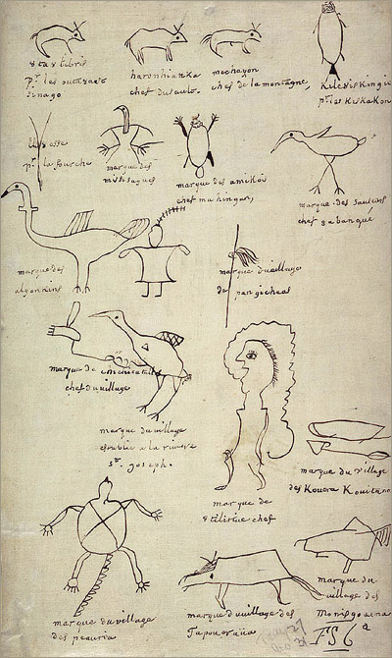
2. The _______________________________________ (1701)
a) __________________________________ were not doing well
( _________________________________)
b) More than __________________________________, from 40 different ________________, gathered near ____________________.They came from the Mississippi Valley, the ________________________, and __________________.
c) Many were lifelong _____________________.
d) They agreed there would be __________________________________ between the _____________________ and the ___________________________.
e) __________________________________ signed the treaty, INCLUDING the _____________.
f) The Iroquois promised to remain neutral in any future conflict between the _____________________ and their former allies, the ____________________________ of __________________________________.

2. The State and the Habitants:
a) The “__________________” people were the ___________________________ in ___________________________.
They had ________________________________________.
b) ___________________ (ways) of control:
To ensure (make sure) that the ___________________ of the colony were followed, the state used 3 principal means of control:
- _____________________________
- _____________________________ (public hangings, public whippings)
- ____________________________________ (Chateau St-Louis, Intendant’s Palace)

