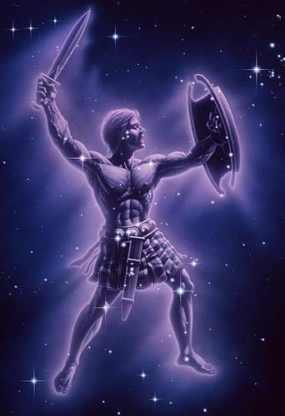

**Represents:**

**Importance to Greek Mythology:**

Was made blind by King Oenopion, vision was restored by the sun God Helios.

Hunted with huntress goddess Artemis and fell in love with her. When he said he would ill every animal of the world the goddess Gaea.

**Facts & Stats:**

Huntsman

Son of the God Poseidon and Eurayle (daughter of King Minos of Crete)

Has the ability to walk on water.

Turned into a constellation.

If you like Orion you might also like the Hindu god Bhadra, who is a god of hunting.

If you liked this, you should also check out…

**Name:** Orion

**Type of being:**

Giant

**Religion/Origin:**

Greek Mythology