Name: ____________________________________ Group: ________

**World War II: ______________**

**Economy**

World War II ended the _________________________________.

**How did this happen?**

a) The Allied forces (_____________________) needed __________, _______________ and _________________________.

b) Canada still had _________________________________________________.

c) It makes more sense to _________________________________________________.

It is only ______________ that ____________________________________________

2. Factors that contributed to industrial development

a) _____________________________________________________

b) _____________________________________________________

**3. Effects on industries and Society**

a) ________________________________________________________________

* Old factories expanded:_______________, _________________, _______________

* New factories were opened: ____________, _______________, _________________

b) **Agricultural growth**:

* Farmers produced ______________________ to export to ______________ and the ________________________.

c) Large increase in the number of ___________________________________________________

4. **Wartime Restrictions**:

a) During the war, people had to __________________________________________.

b) ____________ was ________________ to allow more to be _________________.

c) _________________ and tires were rationed.

d) __________________ were simple:

no unnecessary _____________ or ____________.

e) People were urged to collect the following things to recycle their materials: waste paper, glass, bones, fat, rubber, and metal caps.

**POWER**

1. The ___________________________________________ is signed in _______________

a) This gave Canada Legislative independence.

_____________ did not have to be ________________________________________ anymore.

b) _______________________ is all __________________________ now.

They ______________________________ on _______________________ on their own.

2. Another ___________________________________________?

a) In 1944 _________________________________________________ gets worried about the lack of Canadian troops.

b) He had promised _________ to enact _________________________, because of all the problems it caused in ______________.

c) He issued conscription to ___________________ Canadians.

d) Only _______________ end up getting to the war, because it ends in 1945 and they needed to undergo training beforehand.

e) The ___________________________________ gets a bad reputation in ___________________ and has never won a majority since.

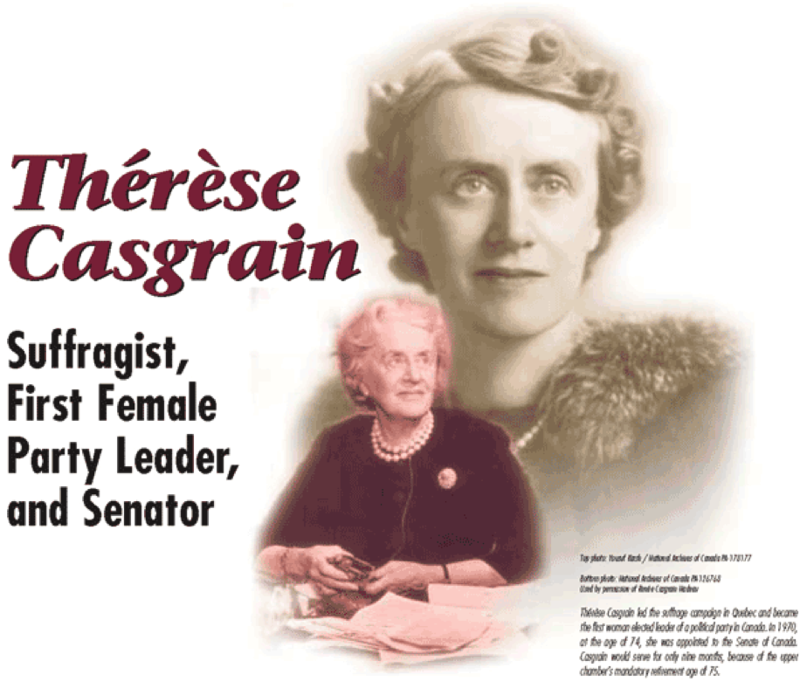**Feminism**

3. _______________________ in Quebec

a) Women in Quebec were the _____________ women in Canada to get ___________________ in ___________________ elections.

b) Even though women started petitioning against the government in the 1920’s.

4. ____________________________________

a) He was the premier of Quebec during the short time that _____________________ was not.

b) He did _________________ during a short amount of time.

c) He used ________________________ to introduce many ___________________ reforms.

d) He gave __________________ the right to vote in Quebec elections in ________________.

e) He is considered a __________________________ of the ______________________________.